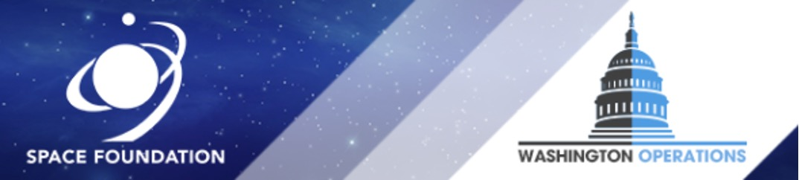
Memorandum
House Committee on Appropriations
Commerce, Justice, Science, and Related Agencies Subcommittee
Fiscal Year 2023 Budget Request for the National Aeronautics and Space Administration
May 17th, 2022
Summary:
Primary hearing purpose provided House Members the opportunity to discuss and question the Administration’s priorities reflected in the FY 2023 Budget for NASA including Climate Change research funding, as well as the continued support of the Artemis Program. Representatives and the Honorable Bill Nelson agreed that NASA was an important player in teaching and inspiring the next generation.

Key Takeaways:
- The Artemis program is generally well supported; however, Artemis milestones and mission objectives are closely being questioned
- Generally, strong bi-partisan support for all NASA Missions and Funding
- Concern showed about the growing space race with China regarding both Moon landings and Mars sample returns

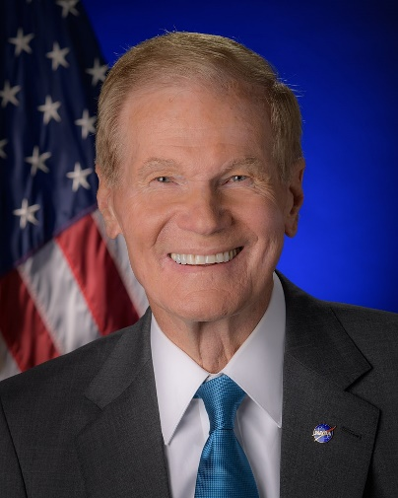
Witness:

Senator Bill Nelson,
NASA Administrator

Members Participating:
Representative Matt Cartwright (D-PA), Commerce, Justice, Science, and Related Agencies Chairman
Representative Robert Aderholt (R-AL) Commerce, Justice, Science, and Related Agencies Ranking Member
Representative Charlie Crist (D-FL)
Representative Ed Case (D-HI)
Representative C.A Ruppersberger (D-MD)
Representative Brenda Lawrence (D-MI)
Representative David Trone (D-MD)
Representative Grace Meng (D-NY)
Representative Steven Palazzo (R-MI)
Representative Ben Cline (R-VA)
Representative Mike Garcia (R-CA)

Opening Statements:
Chairman Cartwright: This budget creates a strong entry for education. The FY 23 proposes an Earth information center and a 10% increase in aeronautics research. Artemis is a national project and must be cost-effective to the taxpayers. Schedule slips and overruns have become common in many agencies, these slips are a concern. NASA needs to manage projects in a way that benefits the taxpayers.

Ranking Member Aderholt: NASA’s success is critical. NASA programs must be properly funded to ensure that threats from China will be met. Must maintain US dominance which means funding Artemis and deep space. NASA must continue to recruit nations to the Artemis Accords. Must have a permanent US presence in Earth’s orbit and partner with aerospace industry partners. It is important to counter Chinese and Russian space endeavors. NASA must cultivate a workforce for tomorrow. FY 2023 falls short in making the future of “NASA strong.”

Spoken Testimony:
Administrator Bill Nelson: Dual track of government and private industry. 2010 NASA bill in Congress. This is a $26 billion budget with aggressive aeronautics and science budgets. Launching the test flight Artemis I this year. Efforts on the lunar lander. NASA will fly the first all-electric plane and the low sonic boom transport.

Member Questions:
Chairman Cartwright: Mobile Launcher (ML2). It has not gone well, does NASA have anything to show for the $500 million cost? Considering FY2023 puts another $200 million into the project. How will NASA ensure progress on the ML2?
- Administrator Nelson: It will cost more money, and NASA is awaiting the IG report to review possible mistakes made. To launch an evolved Artemis SLS, NASA must have a more powerful rocket. The SLS is made to be “evolvable”.
Chairman Cartwright: Considering NASA has 35 projects going on, how can Congress ensure project management stays committed to the task?
- Administrator Nelson: NASA is under constant review

Representative Aderholt: The committee has provided hundreds of millions of dollars for nuclear thermal propulsion but not seen much progress on this technology or a test?
- Administrator Nelson: The President’s recommended budget accounts for a split between nuclear thermal and nuclear electric.
Representative Aderholt: America must have dominance in returning to the moon. When can we expect American boots on the moon?
- Administrator Nelson: NASA is further working on the architecture of our space assets and will be working with the intelligence community.

Representative Meng: It stated that the US will explore space sustainably. How do you intend to shape the discussion around space debris removal?
- Administrator Nelson: Several actors could do better. The ASAT test by China in 2007 was an egregious act. $30 million is being requested for surveillance, research, and development. Coordinating all the agencies will help remedy this issue.

Representative Garcia: Moving to the F-15 and F-16s at Armstrong Base. Those platforms are not just being financial drains but are now becoming serious safety hazards. How can we improve this situation?
- Administrator Nelson: NASA is talking with the DOD and researching which planes, upon retirement from the military, will become available to NASA.

Representative Case: NASA has added several astronauts and host some of the strongest telescopes in the world. Considering the budget has proposed to go up 9% over a $150 million base, do you think this is sufficient to get more women and people of minority into space (Artemis)?
- Administrator Nelson: NASA wants more money for STEM as NASA is an inspirational agency. Money spent is also beneficial to children being enthralled by meeting our astronauts. This interaction is powerful and NASA leverages.

Representative Cline: Rocketlab has been ready to launch for over a year at Wallops, can you explain why the autonomous flight termination system that is required for launch is not ready?
- Administrator Nelson: This issue is stunting the growth. NASA is testing a system for Rocketlab and it is going well. Will have to give you an updated report. Unfortunately, the Wallops bridge has an incline that does not allow for larger rockets. NASA needs help on this.
Representative Cline: Will you please elaborate on Option B for SpaceX?
- Administrator Nelson: There is an award option for SpaceX that allows for another landing in 2026. Some funds are going towards competition for the lander. Once the bid winner is announced for the lander solicitation, NASA will have two options that will compete for being the sustained moon lander

Representative Crist: Long championed fixed-price contracts to keep projects on task. Discuss briefly the importance of government and industry working together for America?
- Administrator Nelson: The 2010 bill discussed earlier allows for this partnership of government and industry.
Representative Crist: New launch date for the capsule on Artemis I?
- Administrator Nelson: It will be unmanned in August and manned in 2024. The unmanned launch will double-check the capsule for safety as it goes through the fiery heat of reentry.

Representative Palazzo: Stennis Space Center is the home of rocket engine testing. NASA’s propulsion testing site infrastructure is important. Can the center can meet testing needs?
- Administrator Nelson: The Stennis Space Center has the power to become a truly special complex just like what happened to Kennedy. Industry and national testing can become very valuable at this location. Asked for help with the Advanced Lend-Lease situation as it is a “herky-jerky” situation.

Representative Lawrence: Dr. Jessica Watkins inspired us all, by becoming the first Black woman to crew a commercial flight. How can minority-owned businesses to interact with the FY 2023 budget for NASA. What is NASA doing to contribute to these businesses getting more of the procurement contracts?
- Administrator Nelson: The team that I brought into NASA has the following statistics: 59% are women and 32% are people of color. NASA has been looking at how we are operating our contracts and procurement and monitoring this process closely.

Chairman Cartwright: Lucy mission to the Trojan asteroids is currently a month ahead of schedule and $57.2 million under expected costs. How did that happen and who gets the credit for that?
- Administrator Nelson: Landsat 9 was also flown before expected and also under budget. This was because of fixed-price contracts and Lucy’s savings are due in part to launch vehicle cost savings and some unused reserves.
Chairman Cartwright: NASA is supporting lander power on the Moon. Several of the opinions are on the table with vertical solar arrays and nuclear fission being in the lead. Are there any planned demonstration missions to the moon?
- Administrator Nelson: If NASA finds water next year, then there is hydrogen and oxygen, but to do that requires a lot of energy. Power would most likely be nuclear.

Representative Aderholt: As NASA looks to expand to a permanent presence on the moon, what role will NASA systems like SLS provide?
- Administrator Nelson: NASA has the biggest rocket (SLS). Will there be others? For the foreseeable future, NASA plans on flying one Artemis flight a year for the next 12 years. For Mars missions, NASA will have to advance propulsion technology
Representative Aderholt: What is the threat posed by China?
- Administrator Nelson: The US is in a space race with China. In the last few years, they have done impressive stuff. They also have a rover on Mars and a space station. They have declared they are going to the Moon.
Representative Aderholt: China’s aggression is also relevant in research. Some of the designs by the Chinese state companies are strikingly similar to American company designs. What are we doing to secure our research?
- Administrator Nelson: Supply chain is a problem, particularly with the situation in Ukraine. Chinese designs are similar to the US, IP has been a problem with China for a long time.

Representative Trone: Maryland is proud to be home to Goddard Space Center. 30 Maryland companies are working on Artemis I launches. Why is it important to have this broad industrial supply network based here?
- Administrator Nelson: Because it works. Look at the James Webb Telescope, it was managed by Goddard.
Representative Trone: Request for less cost-plus contracts and more fixed-price contracts. Outside of existing lunar payload and lunar lander systems. What are other areas that NASA is interested in using fixed point contracts?
- Administrator Nelson: Any interaction with the public. These are incredibly advantageous for NASA and the industry. Currently looking at adaptations of cost-plus options. There are 12-14 contracts for the mission to the Moon and hope to consolidate these into one contract.

Representative Garcia: Will NASA be recovering samples from Mars from the various landers?
- Administrator Nelson: This will be another manifestation of the race with China. Who will return a sample first? NASA has secured a contract for a Mars Ascent Vehicle. Currently deciding how to deposit the samples. Likely use titanium tubes leaving some on the lander and some on the surface to have backups.
Representative Garcia: What is the plan for more nations to sign on to the Artemis Accords? How does the US prevent hostilities with Russia and China so as not to create Star Wars in our solar system?
- Administrator Nelson: 19 countries have signed on and NASA continues to advocate for more. The Artemis Accords are a standing operating procedure out in space. It is no secret that Russia and China’s space endeavors are linked to their military.

Representative Palazzo: Recently stated that cost-plus contracts are a plague, yet the Space Act Agreement is set up as a cost-plus contract. Please elaborate.
- Administrator Nelson: NASA needs to get leaner and meaner. Lucy and Landsat 9 are excellent examples. Not everything is fixed price nor should everything be at cost plus.
Representative Palazzo: NASA must keep “our documents in our hands.” What is NASA doing to ensure that this is not the culture?
- Administrator Nelson: Budget requests $667 million, a 9% increase over the FY22 request. To evolve capabilities and become more secure and efficient.

Representative Aderholt: How does NASA plan to have a healthy workforce without large projects? (SLS, ISS, Space Shuttle)?
- Administrator Nelson: The workforce will be healthy. $8 billion is towards science.
Representative Aderholt: Maintaining strength in space is important as is maintaining a proper cadence for space missions. How does the FY23 budget reflect a commitment to American leadership in space?
- Administrator Nelson: The entire budget reflects it. The public/private partnership extends abilities to push the bounds of human evolution and provide an exciting time.

Chairman Cartwright: Stimulating the young minds is crucial and is NASA #1 job. Looking at the end of the ISS lifetime. Currently, the ISS allows for the opportunity for video calls with school districts. How can NASA ensure this is still possible as a tenant?
- Administrator Nelson: On a commercial station, NASA will be a lessee to several activities but will have certain requirements.

Representative Case: The geopolitical world has shifted on its axis. The current situation requires a rethink of space and space endeavors. Are there risk expenditures the US needs? Are there any collaborations that the US should delink?
- Administrator Nelson: Look at the ISS. Russia controls the propulsion, and the US controls the electricity. Look at the Lunar Gateway. With the changing politics, how will the US keep doing this in partnership? Very carefully. The cosmonauts have been professional as well as the control staff in Moscow. Take it day by day. Space is the one place where humanity can accomplish interesting international things.

Hearing notes written by Alden Findley.

The Space Foundation Washington Operations Team publishes congressional hearing memos as a product for corporate members.

The Washington Operations Team consists of Megan Wenrich, Senior Manager, DC Operations; Elizabeth Anderson, Government Affairs Associate; Alden Findley, Government Intern.

Please reach out to eanderson@spacefoundation.org for more information.

