Memorandum
House Committee on Appropriations
United States Air Force and the United States Space Force Fiscal Year 2023 Budget
May 13th, 2022
Summary:
Primary hearing purpose provided House Members the opportunity to discuss and question the United States Air Force and United States Space Force on the President’s Fiscal Year 2023 Budget request. The Air Force is interested in the divestment of current capabilities in exchange for development of emerging technologies.

Key Takeaways:
- Overall Space Force is projected to receive a 30% budget increase from FY22
- Two-thirds of the Space Force budget request is projected for R&D
- SPACECOM decision was raised, explained they will continue to work through the process
- Hypersonics focused on R&D and improved Hypersonic capability
- McCollum mentioned that the nuclear weapon modernization was important as it would spur on the advancement of conventional platforms.

Witnesses:
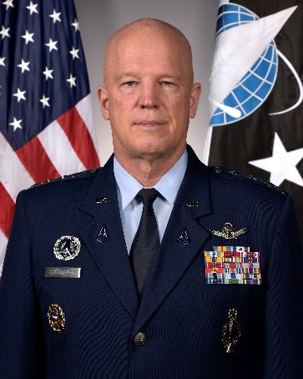
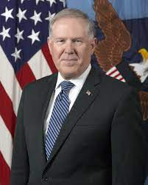
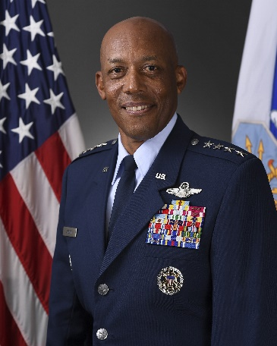

Honorable Frank Kendall, General Charles Q. Brown Jr., General John W. Raymond,
Secretary of the Air Force Chief of Staff of the Air Force Chief of Space Operations,
U.S. Space Force

Members Participating:
Representative Betty McCollum (D-MN), House Committee on Appropriations Chair
Representative Ken Calvert (R-CA), House Committee on Appropriations Ranking Member
Representative C. A. Ruppersberger (D-MD)
Representative Marcy Kaptur (D-OH)
Representative Henry Cuellar (D-TX)
Representative Derek Kilmer (D-WA)
Representative Pete Aguilar (D-CA)
Representative Cheri Bustos (D-IL)
Representative Charlie Crist (D-FL)
Representative Ann Kirkpatrick (D-AZ)
Representative Hal Rogers (R-KY)
Representative Tom Cole (R-OK)
Representative Steve Womack (R-AR)
Representative Robert Aderholt (R-AL)
Representative John Carter (R-TX)
Representative Mario Diaz-Balart (R-FL)

Opening Statements:
Chair McCollum: The budget for Space Force reflects an increase of 30% over FY 2022 Budget. We would like a greater focus on efficiency and cost-effectiveness going forward.

Ranking Member Calvert: Is the US military winding down F-35, A-10 production? Concern of inflation. Approves of software-first approach

Representative Granger: Concern about inflation and weak budget. Retirement of aircraft should be thoughtful so as not to deplete U.S. combat power

Spoken Testimony:
Secretary Kendall: China is increasing its nuclear arsenal and long-range options
- Trying to balance capabilities today and transformation for tomorrow
- Research and Development are considerable portions of the Fiscal 2023 Budget
- Divestment of outdated and ineffective platforms
- As Space Force establishes itself as a branch, that development of a more resilient architecture missile tracking, and communications network is required because of the threats posed by Russia and China
- The deployment of a more advanced battle management network is required and would be strengthened by new missile tracking and Deployment of an advanced battle management network
- The E7 is being requested as an interim AWACS platform replacement
- Important feature of FY 2023 budget is a focus on R&D
- In this budget, the B-21 Raider will enter production

General Brown:
- Collaboration efforts are crucial for the success of Air Force and Space Force objectives
- FY 2023 budget ensures that meaningful capable power is put in the hands of airmen
- The retiring of older platforms strengthens current operational assets

General Raymond:
- This budget request seeks to create space defense architecture
- Information gathered from space is becoming more relevant
- $24.5 Billion for the entire Space Force budget
- Aim to use the largest share of $16 billion for R&D
- Funding for the Space Development Agency will now be included in Space Force Budget
- Increased funding for more resilient communications and missile tracking
- Hybrid-Reserve and Active Service Members

Member Questions:
Chairman McCollum: Previous space systems have been over budget and over time. How can we ensure that Space Force’s five-year plan is executable and reasonable? Does Space Force believe in its ability to utilize its budget properly? What will you prioritize?
- Secretary Kendall: Starting with our missile tracking and communication needs first is crucial. Next define requirements and the work that still needs to be done. Fiscal 2023 is a good start in finding the next new steps.
- General Raymond: Next-Gen GEO has met its performance parameters and completed a critical design review. It is 25 months ahead of schedule.

Ranking Member Calvert:
Concerned about the future of the MQ-9 Reaper. Can you put more definition in the term “survivability”? Are we meeting our geographic combatant commander’s needs? The Airforce justifies buying 4th gen fighters over more “survivable” 5th gen fighters but not 4th gen unmanned assets. Could you expand on this?
- General Brown: I am in contact with the combatant commands. We will continue to use MQ-9s but further discussion can take place in our classified meeting this afternoon. In the debate of 4th vs 5th gen, we must balance our current situation and future. In the past, we have been fighting permissive targets.
Ranking Member Calvert: I would argue most of the world is permissive.

Representative Ruppersberger: As Space Force absorbs the Space Development Agency, how will you ensure that its effectiveness and process will continue?
- General Raymond: Their projects are included in this budget, and they will continue to be able to operate with support making sure they are lean and able to go fast.
Representative Ruppersberger: Secretary Kendall, now that we are two years into Space Force, how might we see this reflected in the budget.
- Secretary Kendall- Further work on the architecture of our space assets and working with the intelligence community.

Representative Kaptur: Starting the Space Force was a challenge, could you give an overview of how it is arranged in the United States?
- General Raymond: Capabilities across the globe. Six major hubs. California, several in Colorado, Florida, New Mexico, Greenland, and Alaska.
Representative Kaptur: Why the reduction in F-35s. Invested interest in the 180th Wing which is a National Guard group. Are they still in consideration?
- This question was taken for the record

Representative Carter: Since 1945, the US has dominated airspace around the world. Now China is progressing. In your opinion, tonight and in the future, are we able to fight and win?
- Secretary Kendall: No adversary should doubt the US. The most formidable fighting force in the world. There is challenge and now the US must move to more capable technologies. China has been watching how project powers since the first Gulf War. The US has to respond and accelerate change. This is evident in the FY 2023 Budget.

Representative Crist: As storms and severe weather become more common, what are the threats and measures to take in the future.
- Secretary Kendall: Taking that into plans, with environmental concerns around the world and these will change the political landscape.

Representative Rogers: The situation in Ukraine. Has this changed the US’s nuclear posture?
- Secretary Kendall: In a short answer, no, however, monitoring Putin’s moves
- General Brown: Slightly higher because of Putin’s rhetoric

Representative Rogers: Forward movement in missile tracking but will the interim solution become a more permanent solution?
- Secretary Kendall: We plan to use the E-7 as an interim solution. China has been advancing equipment that can reach farther and we want to increase our survivability. In the future, we plan to pursue a space-based approach.

Representative Aguilar: Previously stated that China has an asymmetric advantage over the US in hypersonic and it is crucial to be ahead of the adversary. However, the Air Force Hypersonic Launch System has had three failures. In the FY 2023 Budget, the only request is for R&D funding. Will Aero begin production in 2024? Budget requests $115 million for hypersonic development. Are there priorities on hypersonic development?
- Secretary Kendall: There had been three failures and will not commit to production before working out the issues. Hypersonics is more difficult to develop than people would think. China has a different production problem and target set. Looking for the most cost-effective platform. Seeing more success with air-breathing hypersonics. Priority is developing the ability for hypersonics to hit moving targets.

Representative Aderholt: Huntsville, Alabama has the perfect combination of assets for the Space Force. Assuming the GAO report does not change the location selection, what is the timeline for consideration?
- Secretary Kendall: Looking at a very specific list of factors and need to do three months of assessment and then have another month for public comment.
Representative Aderholt: FY 2023 Budget calls for cuts of over 100 aircraft. Concerned about the costs associated with this. The National Guard and Reserve are low-cost options for national defense. Has there been any analysis about the possibility of sending platforms over to them?
- Secretary Kendall: Try to balance our future and present. Looking for ways to be an efficient force.

Hearing notes written by Alden Findley.

The Space Foundation Washington Operations Team publishes congressional hearing memos as a product for corporate members.

The Washington Operations Team consists of Megan Wenrich, Senior Manager, DC Operations; Elizabeth Anderson, Government Affairs Associate; Alden Findley, Government Intern.

Please reach out to eanderson@spacefoundation.org for more information.

